**6432021021 Jiratchaya Prajonkitchai**

**Assignment 5 myDropbox**

**S3 Design**

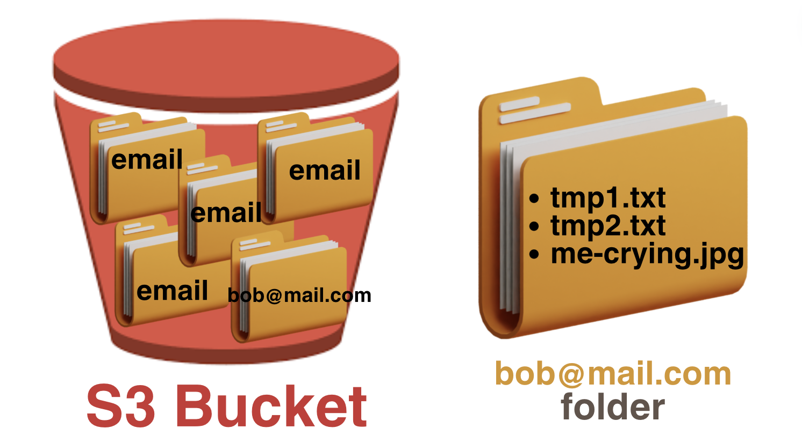

I have decided to organize my S3 bucket to store folders named after users' emails because myDropbox uses email for login authentication, ensuring uniqueness. Each user's files will be stored within a folder named after their email address, **allowing multiple users to store their files in the same S3 bucket** while **easily discerning which files belong to whom**. Additionally, this structure **guarantees that if User A uploads a file and User B uploads another file with the same name, they are treated as separate objects in the bucket.**

S3 bucket Organization

**Overview System**

**API**

